Project Reporton

**UNIVERSITY STUDENT MANAGEMENT SYSTEM**

Developed by

**Modh Dishant (IT-070) Department of IT, DD University**

**Panchal Jay (IT-079) Department of IT, DD University**

**Guided By**

**Internal Guide:**

**Prof. Vidhi B. Chaudhari**

**Department of Information Technology**

**Faculty of Technology**

**DD University**



**Department of Information Technology**

**Faculty of Technology, Dharmsinh Desai University**

**College Road, Nadiad-387001**

**October-2020**

## DHARMSINH DESAI UNIVERSITY

**NADIAD-387001, GUJARAT**



# CERTIFICATE

This is to certify that the project entitled “**UNIVERSITY STUDENT MANAGEMENT SYSTEM**” is benefited

report of the work carried out by

1) **Mr Dishant Modh,** Student ID No: **18ITUBN116**

2) **Mr. Jay Panchal**, Student ID No: **18ITUBS003**

of Department of Information Technology, semester V, under the guidance and supervision for the subject Database Management System. They were involved in Project training during academic year 2020-2021.

### Prof. Vidhi B. Chaudhari

(Project Guide)

Department of Information Technology,

Faculty of Technology,

Dharmsinh Desai University, Nadiad Date:

### Prof. Vipul Dabhi

Head, Department of Information Technology,

Faculty of Technology,

Dharmsinh Desai University, Nadiad Date:

# 

# ACKNOWLEDGEMENT

We would like to give our sincere acknowledgement to everybody responsible for the successful completion of our project “UNIVERSITY STUDENT MANAGEMENT SYSTEM”

The success and final outcome of this project required a lot of guidance and assistance from many people and we are extremely privileged to have got this all along the completion of  this project.

We owe our deep gratitude to our project guide Prof. Roshni M. Raval, who took been interest on our project work and guided us all along till the completion of our project work  by providing all the necessary help for developing a good Database System.

We would also like to thank all our lecturers.

Finally we convoy our acknowledgement to all our friends and family members who directly or indirectly associated with us in the successful completion of the project.We  thank one and all.

Thanking You,

Modh Dishant (IT-070)

Panchal Jay (IT-079)

### 

### TABLE OF CONTENTS

I. Certificate 2

II. Acknowledgement ……………………3

1. **SYSTEM OVERVIEW ............................................................................................**

1.1 Current system ......................................................................................................5

1.2 Objectives of the Proposed System ......................................................................5

* 1. Advantages of the Proposed system (over current) ...........................................5

1. **E-R DIAGRAM** .............................................................................................................6

**3.DATA DICTIONARY** ......................................................................................................7

**4.SCHEMA DIAGRAM** .....................................................................................................11

**5.DATABASE IMPLEMENTION............................................................................**

5.1 Create Schema .....................................................................................................12

5.2 Insert Data values ................................................................................................15

5.3 Queries (Based on functions, group by, having, joins, sub query etc.) ...............23

5.4 PL/SQL Block (Procedures and Exception Handling) ...........................................26

5.5 Function …...........................................................................................................28

5.6 Cursors ................................................................................................................29

* 1. Trigger ................................................................................................................30

**6.FUTURE ENHANCEMENTS OF THE SYSTEM** ....................................................................32

**7.BIBLIOGRAPHY**................................................................................................................33

**1.SYSTEM OVERVIEW**

**1.1 CURRENT SYSTEM**

University Student Management System is engineered to effectively administer every aspect of a University\College Student problem which they face while entering into new University\College at any unknown place.

Any Student who enters into new University/College they face some basic and huge problem like Finding PG\Hostel, Senior Contact for some notes, College Book’s for reading or if they want to buy them, and also for eating it will show restaurants.

It will also show the different type of Activity organised by his/her particular University/College and it also

show the different Event’s occurring in his/her University/College.

**1.2 OBJECTIVES OF THE PROPOSED SYSTEM**

* Students can easily find Broker’s for their Living, can easily get information for nearby restaurant for their Eating.
* Getting contact of their Senior form which, they can get help.
* They can contact their Activity Head easily.

**1.3 ADVANTAGES OF STUDENT MANAGEMENT SYSTEM**

* Through this system we try to achieve the below objectives
* To help students by providing study material from their seniors
* Students can know all the available restaurants and caters for their breakfast, lunch and dinner.
* Students can explore their interest by doing activities
* Students can find rent house or hostel easily.
* Students can also get their second-hand study material help easily.
* Also, they find Stationery and Xerox stuff easily.
* By using this system students can easily figure out which stationary or restaurants or Hostels are good for them, facility wise as well as price wise.

**2.ER DIAGRAM**

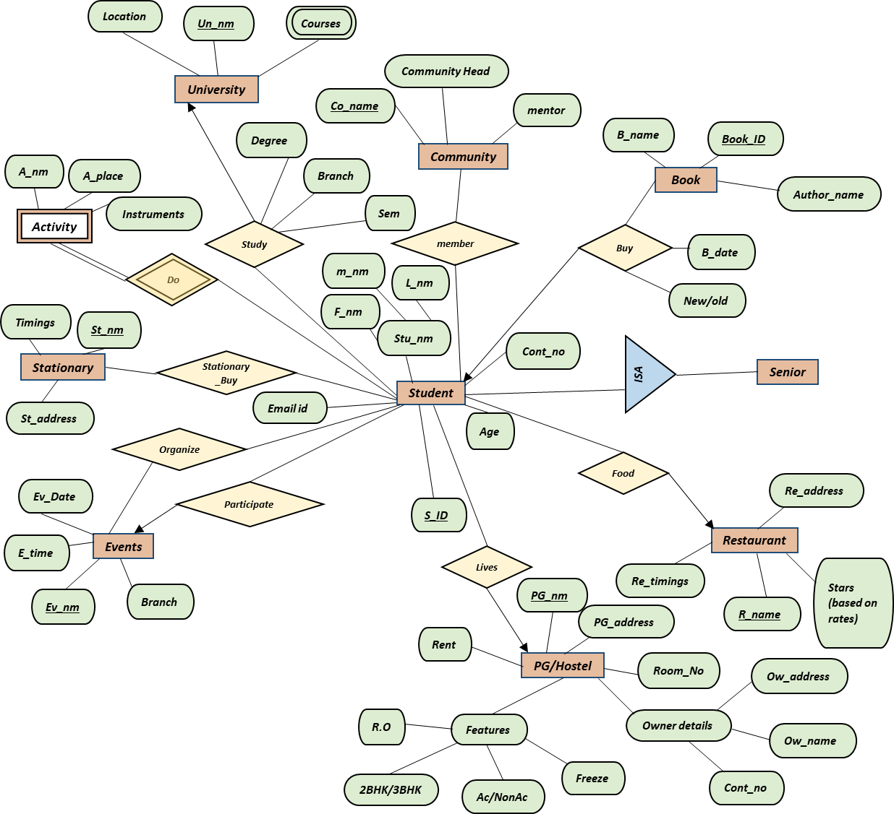

***Admin***

***Manage***

***Manage***

***Manage***

***Manage***

***Manage***

***Manage***

***Manage***

***Manage***

***Manage***

***Help***

***Username***

***Password***

**\***

**1**

**\***

**\***

**\***

**\***

**\***

**\***

**\***

**\***

**\***

**\***

**\***

**\***

**\***

**\***

**\***

**\***

**\***

**\***

**\***

**\***

**\***

**\***

**\***

**\***

**\***

**\***

**\***

**\***

**\***

**\***

**\***

**\***

**1**

**1**

**1**

**1**

**3. REALATIONAL** **DATA** **BASE**

**3.1 University**

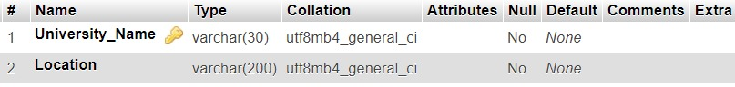

**3.2 Activity**

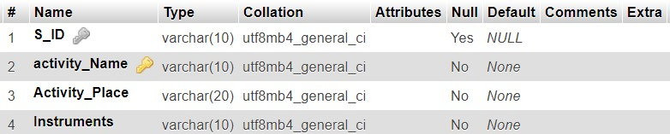

**3.3 Courses**

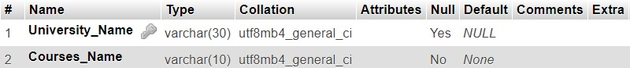

**3.4 Stationary**

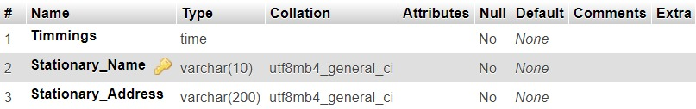

**3.5 Events**

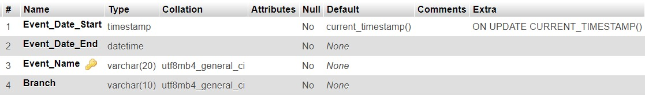

**3.6 Book**

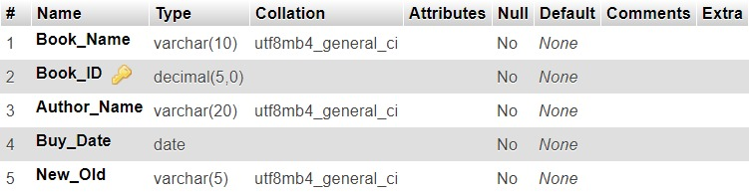

**3.7 Restaurant**

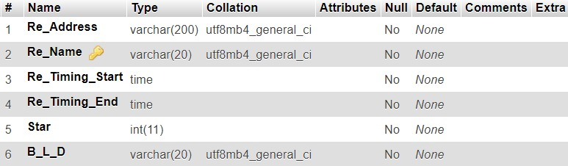

**3.8 Pg_Hostel**

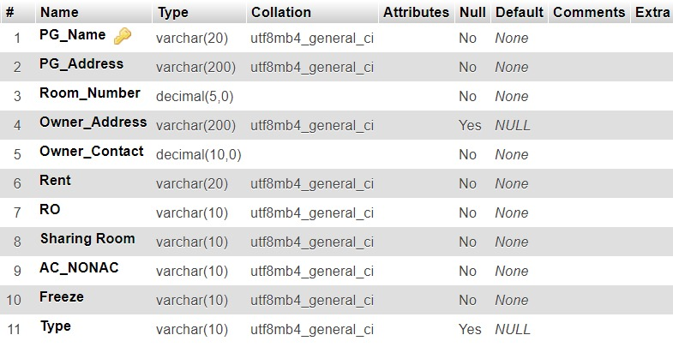

**3.9 Community**

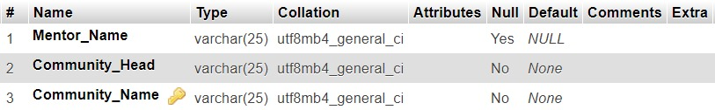

**3.10 Student**

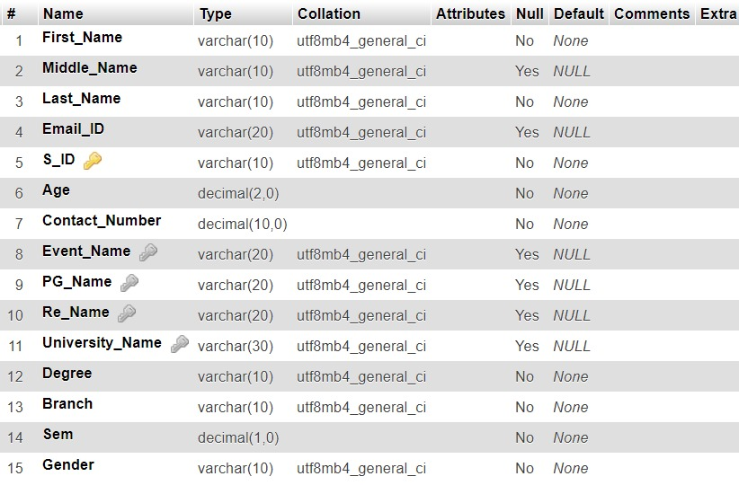

**3.11 Stationary_Buy**

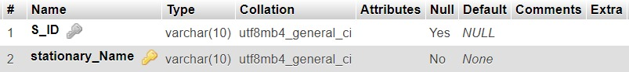

**3.12 Admin**

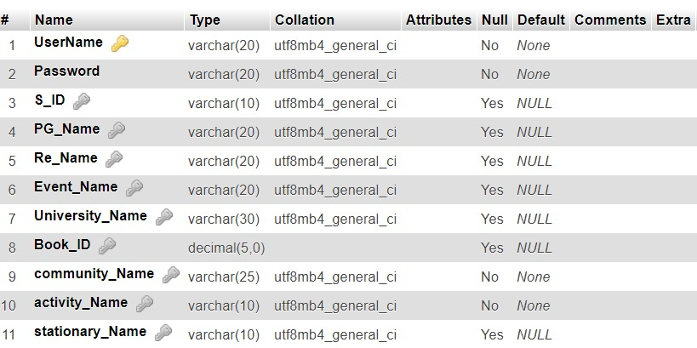

**3.13 Member**

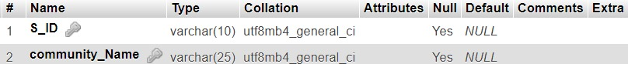

**3.14 Organize**

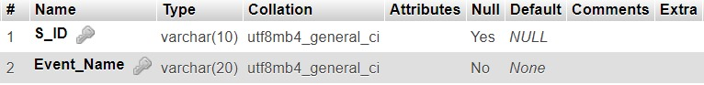

**4.SCHEMA DIAGRAM**

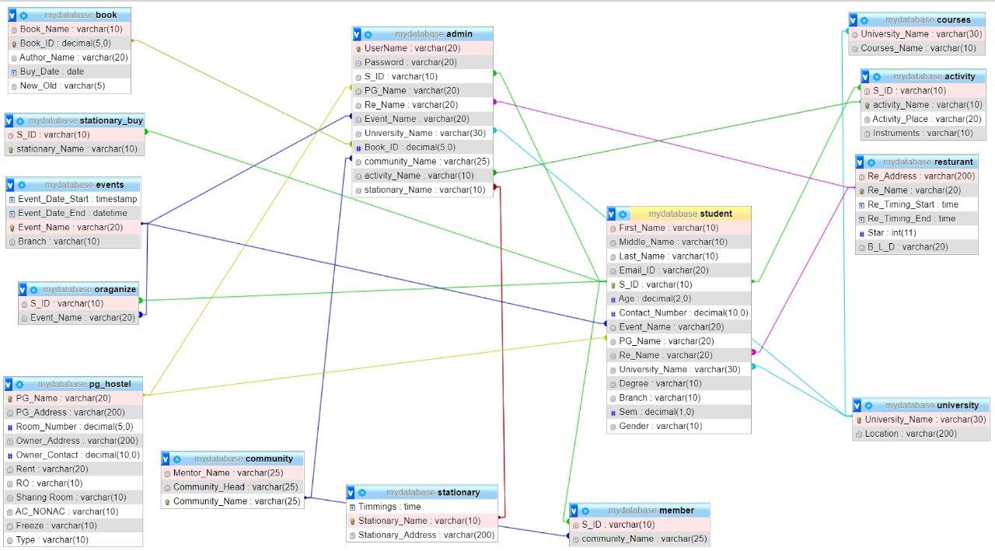

**5.DATABASE IMPLEMENTATION**

**5.1 CREATE SCHEMA**

**5.1.1 Student**

CREATE TABLE STUDENT (First_Name VARCHAR(10) NOT NULL, Middle_Name VARCHAR(10) DEFAULT NULL, Last_Name VARCHAR(10) NOT NULL, Email_ID VARCHAR(20) DEFAULT NULL, S_ID VARCHAR(10) PRIMARY KEY, Age DECIMAL(2) NOT NULL, Contact_Number DECIMAL(10) NOT NULL, Event_Name VARCHAR(10), PG_Name VARCHAR(20), Re_Name VARCHAR(10), University_Name VARCHAR(30), Degree VARCHAR(10) NOT NULL, Branch VARCHAR(10) NOT NULL, Sem DECIMAL(1) NOT NULL);

ALTER TABLE `student` ADD CONSTRAINT `student1` FOREIGN KEY (`Event_Name`) REFERENCES `events` (`Event_Name`);

ALTER T)ABLE `student` ADD CONSTRAINT `student2` FOREIGN KEY (`PG_Name`) REFERENCES `pg_hostel` (`PG_Name`);

ALTER TABLE `student` ADD CONSTRAINT `student3` FOREIGN KEY (`Re_Name`) REFERENCES `resturant` (`Re_Name`);

ALTER TABLE `student` ADD CONSTRAINT `student4` FOREIGN KEY (`University_Name`) REFERENCES `university` (`University_Name`);

**5.1.2 Community**

CREATE TABLE COMMUNITY (Mentor_Name VARCHAR(25) DEFAULT NULL, Community_Head VARCHAR(25) NOT NULL, Community_Name VARCHAR(25) PRIMARY KEY);

**5.1.3 Stationary**

CREATE TABLE STATIONARY (Timmings TIME NOT NULL, Stationary_Name VARCHAR(10) PRIMARY KEY, Stationary_Address VARCHAR(200) NOT NULL);

**5.1.4 Event**

CREATE TABLE EVENTS(Event_Date_Start TIMESTAMP NOT NULL, Event_Date_End DATETIME NOT NULL, Event_Name VARCHAR(20) PRIMARY KEY, Branch VARCHAR(10) NOT NULL);

**5.1.5 Book**

CREATE TABLE BOOK (Book_Name VARCHAR(10) NOT NULL, Book_ID DECIMAL(5) PRIMARY KEY, Author_Name VARCHAR(20) NOT NULL, Buy_Date DATE NOT NULL, New_Old VARCHAR(5) NOT NULL);

**5.1.6 Pg_Hostel**

CREATE TABLE PG_HOSTEL (PG_Name VARCHAR(20) PRIMARY KEY, PG_Address varchar(200) NOT NULL, Room_Number DECIMAL(5) NOT NULL, Owner_Address VARCHAR(200) DEFAULT NULL, Owner_Contact DECIMAL(10) NOT NULL, Rent VARCHAR(20) NOT NULL, RO VARCHAR(10) NOT NULL, TWO_BHK_3BHK VARCHAR(10) NOT NULL, AC_NONAC VARCHAR(10) NOT NULL, Freeze VARCHAR(10) NOT NULL);

**5.1.7 Restaurant**

CREATE TABLE Resturant (Re_Address VARCHAR(200) NOT NULL, Re_Name VARCHAR(20) PRIMARY KEY, Re_Timing_Start TIME NOT NULL, Re_Timing_End TIME NOT NULL, Star INT NOT NULL, B_L_D VARCHAR(20) NOT NULL);

**5.1.8 Admin**

CREATE TABLE ADMIN (UserName VARCHAR(20) PRIMARY KEY, Password VARCHAR(20) NOT NULL, S_ID VARCHAR(10), PG_Name VARCHAR(20), Re_Name VARCHAR(20), Event_Name VARCHAR(20), University_Name VARCHAR(10), Book_ID DECIMAL(5), community_Head VARCHAR(10) NOT NULL, Acitvity_Name VARCHAR(10) NOT NULL, stationary_Name VARCHAR(10))

ALTER TABLE `admin` ADD CONSTRAINT `amin1213` FOREIGN KEY (`stationary_Name`) REFERENCES `stationary` (`stationary_Name`)

**5.1.9 Organize**

CREATE TABLE Oraganize(S_ID VARCHAR(10), Event_Name VARCHAR(10) PRIMARY KEY)

**5.1.10 Stationary_Buy**

CREATE TABLE stationary_Buy (S_ID VARCHAR(10), stationary_Name VARCHAR(10) PRIMARY KEY)

ALTER TABLE `stationary_buy` ADD CONSTRAINT `sb` FOREIGN KEY (`S_ID`) REFERENCES `student` (`S_ID`

**5.1.11 Member**

CREATE TABLE member (S_ID VARCHAR(10),community_Name VARCHAR(25));

ALTER TABLE `member` ADD CONSTRAINT `m2` FOREIGN KEY (`S_ID`) REFERENCES `student` (`S_ID`);

ALTER TABLE `member` ADD CONSTRAINT `m3` FOREIGN KEY (`community_Name`) REFERENCES `community` (`community_Name`);

**5.1.12 University**

CREATE TABLE University (University_Name VARCHAR(30) PRIMARY KEY, Location VARCHAR(200) NOT NULL)

**5.1.13 Courses**

CREATE TABLE Courses (University_Name VARCHAR(30), Courses_Name VARCHAR(10) NOT NULL)

ALTER TABLE `courses` ADD CONSTRAINT `COURSES` FOREIGN KEY (`University_Name`) REFERENCES `university` (`University_Name`)

**5.1.14 Activity**

CREATE TABLE Activity (S_ID VARCHAR(10), Activity_Name VARCHAR(10) PRIMARY KEY, Activity_Place VARCHAR(20) NOT NULL, Instruments VARCHAR(10) NOT NULL)

**5.2 INSERT DATA VALUE**

**5.2.1 Student**

INSERT INTO `student`(`First_Name`, `Middle_Name`, `Last_Name`, `Email_ID`, `S_ID`, `Age`, `Contact_Number`, `Event_Name`, `PG_Name`, `Re_Name`, `University_Name`, `Degree`, `Branch`, `Sem`) VALUES ('Dishant','H','Modh','dishant@gmail.com','1', 18, 9512100731,'BreakUp Day','Royal Care','Prime Dinning Hall','Dharmsinh Desai','B.Tech','IT',5,’Male’ );

INSERT INTO `student`VALUES ('Twiency','','Korat','trkorat76@gmail.com','2', 18, 9428666531,'Coding war','Blossom','Hotel Vandan','IIT-Gandhinagar','B.Tech','CSE',5,'Female');

INSERT INTO `student`VALUES ('Divyesh','D','Chotaliya','dc2310@gmail.com','3', 17, 6356275041,'Cycle Marathon','Shakti','Law Canteen','Nirma','B.Tech','CS',7,'Male' );

INSERT INTO `student` VALUES ('Jay','','Panchal','jaypanchal@gmail.com','4', 22, 9586986565,'Falicific','Aarav Hostel','Panihari restaurant','GMIT','B.Tech','IT',1 ,'Male');

INSERT INTO `student`VALUES ('Shivani','K','Modi','shivanimodi@gmail.com','5', 19, 7889455622,'Photography','Samaras','Virat fast-food','DaIICT','B.Tech','ICT',3,'Female' );

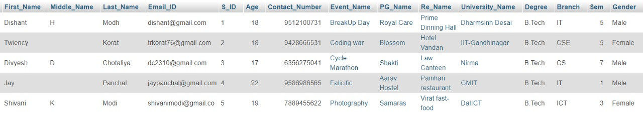

**5.2.2 Community**

INSERT INTO `community`(`Mentor_Name`, `Community_Head`, `Community_Name`) VALUES ('Harsh Raval', 'Dhrumil Shah', 'Drama Kids');

INSERT INTO `community`(`Mentor_Name`, `Community_Head`, `Community_Name`) VALUES ('Devarshi Sathiya', 'Dhrumit Patel', 'Coder Gang');

INSERT INTO `community`(`Mentor_Name`, `Community_Head`, `Community_Name`) VALUES ('Priyank Shah', 'Raghavendra Gohil', 'DDU Connet');

INSERT INTO `community`(`Mentor_Name`, `Community_Head`, `Community_Name`) VALUES ('Krutik Bhatt', 'Archit Italiya', 'Photo Rider');

INSERT INTO `community`(`Mentor_Name`, `Community_Head`, `Community_Name`) VALUES ('Jay Lakhani', 'Jay Mangukia', 'DSC');

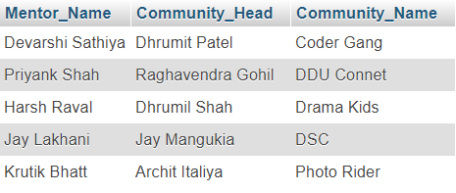

**5.2.3 Stationary**

INSERT INTO `stationary`(`Timmings`, `Stationary_Name`, `Stationary_Address`) VALUES ('09:00:00','Samir','Shivalik Building, 1, Atabhai Rd, Bhavnagar');

INSERT INTO `stationary`(`Timmings`, `Stationary_Name`, `Stationary_Address`) VALUES ('11:00:00','Mahajan','Nirma University, Ahmedabad');

INSERT INTO `stationary`(`Timmings`, `Stationary_Name`, `Stationary_Address`) VALUES ('09:00:00','Vidhyarthi','Shop No.1653, Shopping Center, Sector-3/A, Sector 3, Gandhinagar');

INSERT INTO `stationary`(`Timmings`, `Stationary_Name`, `Stationary_Address`) VALUES ('10:00:00','Jay Book ',' Sector 11, Gandhinagar');

INSERT INTO `stationary`(`Timmings`, `Stationary_Name`, `Stationary_Address`) VALUES ('09:00:00','Student Book','13/14, Chanakya Complex, Vania Vad, Nairobi Colony, Nadiad');

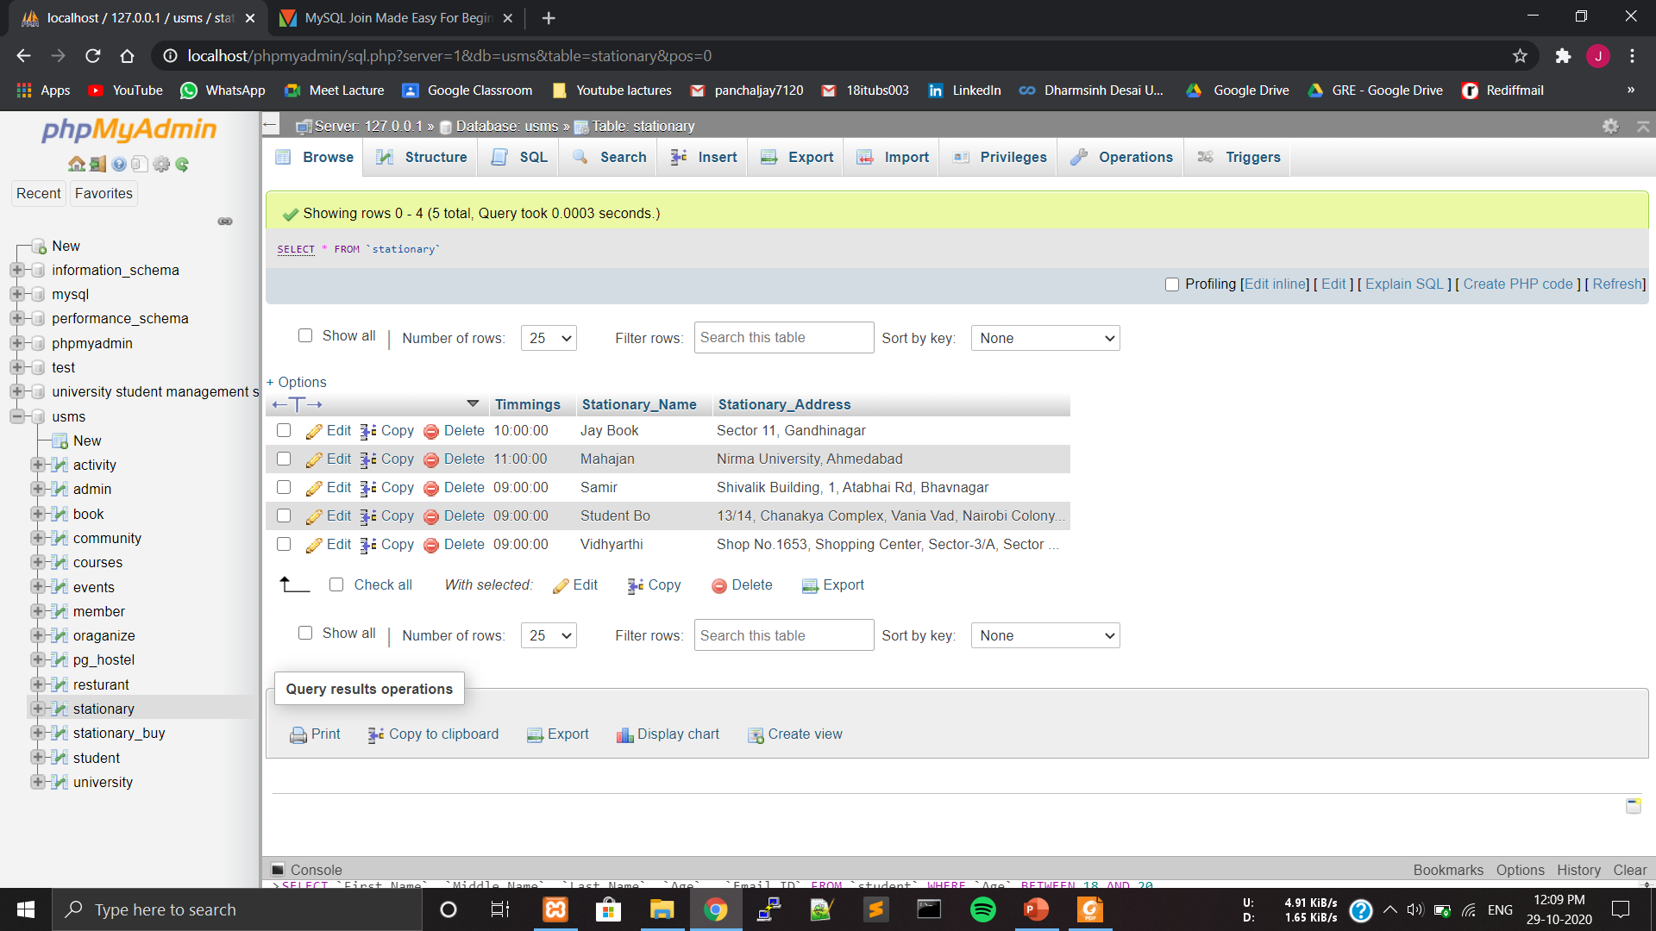

**5.2.4 Event**

INSERT INTO `events`(`Event_Date_Start`, `Event_Date_End`, `Event_Name`, `Branch`) VALUES ('2019-12-09 10:00:00','2019-12-09 22:00:00','Cycle Marathon','All');

INSERT INTO `events`(`Event_Date_Start`, `Event_Date_End`, `Event_Name`, `Branch`) VALUES ('2020-01-26 07:00:00','2020-01-27 18:00:00','Photography','All');

INSERT INTO `events`(`Event_Date_Start`, `Event_Date_End`, `Event_Name`, `Branch`) VALUES ('2020-02-14 10:00:00','2020-02-15 22:00:00','BreakUp Day','All');

INSERT INTO `events`(`Event_Date_Start`, `Event_Date_End`, `Event_Name`, `Branch`) VALUES ('2020-03-07 18:00:00','2020-03-17 23:00:00','Falicific','All');

INSERT INTO `events`(`Event_Date_Start`, `Event_Date_End`, `Event_Name`, `Branch`) VALUES ('2020-03-18 10:00:00','2020-03-20 22:00:00','Coding war','IT');

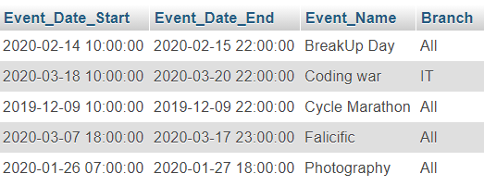

**5.2.5 Book**

INSERT INTO `book`(`Book_Name`, `Book_ID`, `Author_Name`, `Buy_Date`, `New_Old`) VALUES ('ANSI C', 1 , 'E Balaguruswami', '2020-07-01', 'New');

INSERT INTO `book`(`Book_Name`, `Book_ID`, `Author_Name`, `Buy_Date`, `New_Old`) VALUES ('DDC', 2 , 'Morris Manno', '2019-06-26', 'Old');

INSERT INTO `book`(`Book_Name`, `Book_ID`, `Author_Name`, `Buy_Date`, `New_Old`) VALUES ('DAA', 3 , 'Cormen', '2020-08-05','Old');

INSERT INTO `book`(`Book_Name`, `Book_ID`, `Author_Name`, `Buy_Date`, `New_Old`) VALUES ('VILE BODIES', 4 , 'EVELYN WAUGH', '2020-02-01', 'New');

INSERT INTO `book`(`Book_Name`, `Book_ID`, `Author_Name`, `Buy_Date`, `New_Old`) VALUES ('PALE FIRE', 5 , 'VLADIMIR NABOKOV', '2020-12-31', 'New');

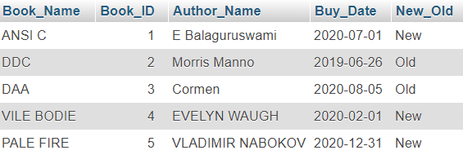

**5.2.6 pg_hostel**

INSERT INTO `pg_hostel` VALUES ('Royal Care','Canal Rd, Nadiad', 1407, 'Canal Rd, Nadiad', 02686544552, '100000/year' , 'Yes','3 Sharing','Both','Yes','Boys');

INSERT INTO `pg_hostel` VALUES ('Aarav Hostel','Canal Rd, Bhavnagar', 7, 'Canal Rd, Bhavnagar', 02686544557, '74500/year' , 'Yes','3 Sharing','Both','Yes','Both');

INSERT INTO `pg_hostel` VALUES ('Blossom','ITC centre, Anna Salai, Gandhinagar', 17, 'ITC centre, Anna Salai, Gandhinagar', 02686544570, '50000/year' , 'Yes','2 Sharing','Both','Yes','Girl');

INSERT INTO `pg_hostel` VALUES ('Samaras','Kalavad Road, Gandhinagar', 14, 'Kalavad Road, Gandhinagar', 02686544100, '25000/year' , 'Yes','3 Sharing','Both','Yes','Girls');

INSERT INTO `pg_hostel` VALUES ('Shakti','Nehru road, Ahemdabad', 1407, 'Nehru road, Ahemdabad', 02686545555, '50000/year' , 'Yes','3 Sharing','Both','Yes','Boys');

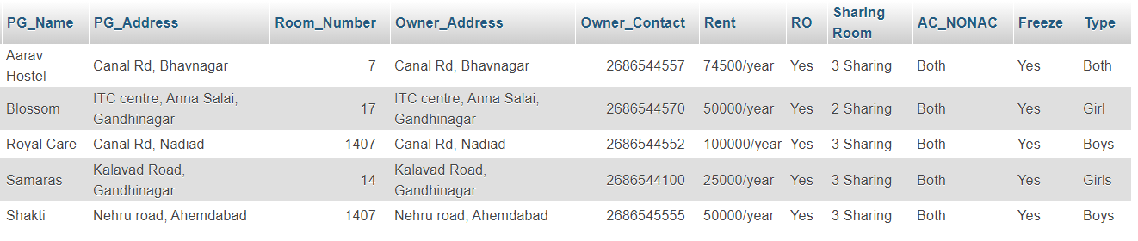

**5.2.7 Restaurant**

INSERT INTO `resturant`(`Re_Address`, `Re_Name`, `Re_Timing_Start`, `Re_Timing_End`, `Star`, `B_L_D`) VALUES ('Ground Floor, Prime Square,Opp. Amba Ashram,Uttarsanda Road, near DDIT College, Nadiad','Prime Dinning Hall','10:30:00','22:00:00', 4, 'All');

INSERT INTO `resturant`(`Re_Address`, `Re_Name`, `Re_Timing_Start`, `Re_Timing_End`, `Star`, `B_L_D`) VALUES ('DA IICT Rd, Infocity, Gandhinagar','Virat fast-food','10:00:00','23:00:00', 4 , 'All');

INSERT INTO `resturant`(`Re_Address`, `Re_Name`, `Re_Timing_Start`, `Re_Timing_End`, `Star`, `B_L_D`) VALUES ('Diversion Rd, Gandhinagar','Hotel Vandan','11:00:00','23:30:00', 3, 'All');

INSERT INTO `resturant`(`Re_Address`, `Re_Name`, `Re_Timing_Start`, `Re_Timing_End`, `Star`, `B_L_D`) VALUES ('Nirma University, Nirma University Rd, Ahmedabad','Law Canteen','08:00:00','20:00:00', 4.5, 'All');

INSERT INTO `resturant`(`Re_Address`, `Re_Name`, `Re_Timing_Start`, `Re_Timing_End`, `Star`, `B_L_D`) VALUES ('Panihari Restaurant, Nr. Gyanmanjari School, Kaliyabid, Bhavnagar','Panihari Restaurant','08:00:00','23:00:00', 4, 'All');

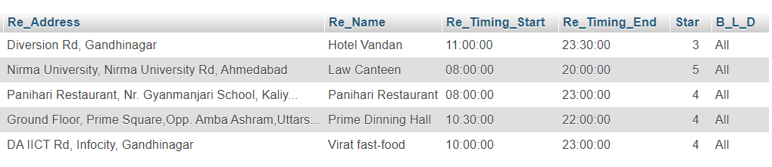

**5.2.8 Admin**

INSERT INTO `admin`(`UserName`, `Password`, `S_ID`, `PG_Name`, `Re_Name`, `Event_Name`, `University_Name`, `Book_ID`, `community_Name`, `activity_Name`, `stationary_Name`) VALUES ('Admin', 'admin1','1','Aarav Hostel','Prime Dinning Hall','BreakUp day','Dharmsinh Desai','1','Drama Kids','Cricket','Student Bo');

INSERT INTO `admin`(`UserName`, `Password`, `S_ID`, `PG_Name`, `Re_Name`, `Event_Name`, `University_Name`, `Book_ID`, `community_Name`, `activity_Name`, `stationary_Name`) VALUES ('Admin1', 'admin1','2','Blossom','Hotel Vandan','Coding war','IIT-Gandhinagar','2','Coder Gang','Badminton','Jay Book');

INSERT INTO `admin`(`UserName`, `Password`, `S_ID`, `PG_Name`, `Re_Name`, `Event_Name`, `University_Name`, `Book_ID`, `community_Name`, `activity_Name`, `stationary_Name`) VALUES ('Admin2', 'admin1','3','Shakti','Law Canteen','Cycle Marathon','Nirma','3','DDU Connet','Football','Mahajan');

INSERT INTO `admin`(`UserName`, `Password`, `S_ID`, `PG_Name`, `Re_Name`, `Event_Name`, `University_Name`, `Book_ID`, `community_Name`, `activity_Name`, `stationary_Name`) VALUES ('Admin3', 'admin1','4','Aarav Hostel','Panihari Restaurant','Falicific','GMIT','4','Photo rider','Basketball','Samir');

INSERT INTO `admin`(`UserName`, `Password`, `S_ID`, `PG_Name`, `Re_Name`, `Event_Name`, `University_Name`, `Book_ID`, `community_Name`, `activity_Name`, `stationary_Name`) VALUES ('Admin4', 'admin1','5','Samaras','Virat fast-food','Photography','DaIICT','5','DSC','Music','Vidhyarthi');

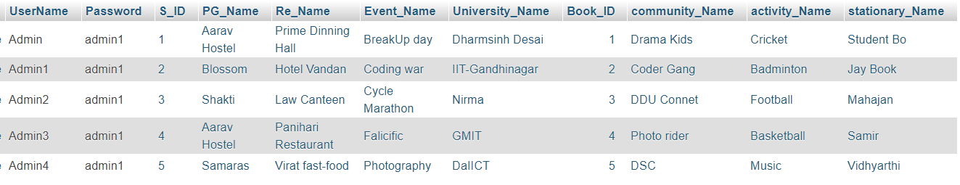

**5.2.9 Organize**

INSERT INTO `member`(`S_ID`, `Event_Name`) VALUES ('1','BreakUp Day');

INSERT INTO `member`(`S_ID`, `Event_Name`) VALUES ('2','Coding war');

INSERT INTO `member`(`S_ID`, `Event_Name`) VALUES ('3','Cycle Marathon');

INSERT INTO `member`(`S_ID`, `Event_Name`) VALUES ('4','Falicicfic');

INSERT INTO `member`(`S_ID`, `Event_Name`) VALUES ('5','Photography');

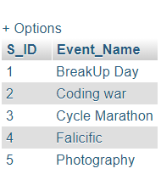

**5.2.10 Stationary_Buy**

INSERT INTO `stationary_buy`(`S_ID`, `stationary_Name`) VALUES (‘1’,’Student Bo’);

INSERT INTO `stationary_buy`(`S_ID`, `stationary_Name`) VALUES (‘2’, ‘Jay Book’);

INSERT INTO `stationary_buy`(`S_ID`, `stationary_Name`) VALUES (‘3’,’Mahajan’);

INSERT INTO `stationary_buy`(`S_ID`, `stationary_Name`) VALUES (‘4’,’Samir’);

INSERT INTO `stationary_buy`(`S_ID`, `stationary_Name`) VALUES (‘5’,’Vidhyarthi’);

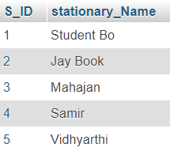

**5.2.11 Member**

INSERT INTO `member`(`S_ID`, `community_Name`) VALUES ('1','Drama Kids');

INSERT INTO `member`(`S_ID`, `community_Name`) VALUES ('2','Coder Gang');

INSERT INTO `member`(`S_ID`, `community_Name`) VALUES ('3','DDU Connet');

INSERT INTO `member`(`S_ID`, `community_Name`) VALUES ('4','Photo Rider');

INSERT INTO `member`(`S_ID`, `community_Name`) VALUES ('5','DSC');

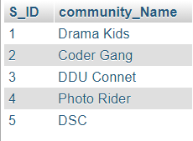

**5.2.12 University**

INSERT INTO `university`(`University_Name`, `Location`) VALUES ('Dharmsinh Desai', 'Nadiad');

INSERT INTO `university`(`University_Name`, `Location`) VALUES ('GMIT', 'Survey No.30, Sidsar Road, near Iscon Eleven, Bhavnagar');

INSERT INTO `university`(`University_Name`, `Location`) VALUES ('DaIICT', 'near, DAIICT-campus, Reliance Cross Rd, Gandhinagar');

INSERT INTO `university`(`University_Name`, `Location`) VALUES ('Nirma', 'Sarkhej - Gandhinagar Hwy, Gota, Ahmedabad');

INSERT INTO `university`(`University_Name`, `Location`) VALUES ('IIT-Gandhinagar', ' Indian Institute of Technology, Palaj');

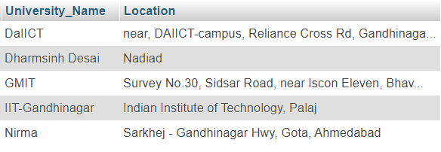

**5.2.13 Courses**

INSERT INTO `courses`(`University_Name`, `Courses_Name`) VALUES ('DaIICT','ICT');

INSERT INTO `courses`(`University_Name`, `Courses_Name`) VALUES ('DaIICT','ICT-CS');

INSERT INTO `courses`(`University_Name`, `Courses_Name`) VALUES ('DaIICT','MnC');

INSERT INTO `courses`(`University_Name`, `Courses_Name`) VALUES ('Dharmsinh Desai','CH');

INSERT INTO `courses`(`University_Name`, `Courses_Name`) VALUES ('Dharmsinh Desai','CE');

INSERT INTO `courses`(`University_Name`, `Courses_Name`) VALUES ('Dharmsinh Desai','IT');

INSERT INTO `courses`(`University_Name`, `Courses_Name`) VALUES ('Dharmsinh Desai','MH');

INSERT INTO `courses`(`University_Name`, `Courses_Name`) VALUES ('Dharmsinh Desai','EC');

INSERT INTO `courses`(`University_Name`, `Courses_Name`) VALUES ('Dharmsinh Desai','IC');

INSERT INTO `courses`(`University_Name`, `Courses_Name`) VALUES ('Dharmsinh Desai','Civil');

INSERT INTO `courses`(`University_Name`, `Courses_Name`) VALUES ('Dharmsinh Desai','BCA');

INSERT INTO `courses`(`University_Name`, `Courses_Name`) VALUES ('Dharmsinh Desai','MBA');

INSERT INTO `courses`(`University_Name`, `Courses_Name`) VALUES ('Dharmsinh Desai','MCA');

INSERT INTO `courses`(`University_Name`, `Courses_Name`) VALUES ('Dharmsinh Desai','BDS');

INSERT INTO `courses`(`University_Name`, `Courses_Name`) VALUES ('Dharmsinh Desai','MBBS');

INSERT INTO `courses`(`University_Name`, `Courses_Name`) VALUES ('Nirma','CS');

INSERT INTO `courses`(`University_Name`, `Courses_Name`) VALUES ('Nirma','EC');

INSERT INTO `courses`(`University_Name`, `Courses_Name`) VALUES ('Nirma','CH');

INSERT INTO `courses`(`University_Name`, `Courses_Name`) VALUES ('GMIT','CE');

INSERT INTO `courses`(`University_Name`, `Courses_Name`) VALUES ('GMIT','IT');

INSERT INTO `courses`(`University_Name`, `Courses_Name`) VALUES ('GMIT','Civil');

INSERT INTO `courses`(`University_Name`, `Courses_Name`) VALUES ('IIT-Gandhinagar','CSE');

INSERT INTO `courses`(`University_Name`, `Courses_Name`) VALUES ('IIT-Gandhinagar','CH');

INSERT INTO `courses`(`University_Name`, `Courses_Name`) VALUES ('IIT-Gandhinagar','Civil');

INSERT INTO `courses`(`University_Name`, `Courses_Name`) VALUES ('IIT-Gandhinagar','Biological Engg.');

INSERT INTO `courses`(`University_Name`, `Courses_Name`) VALUES ('IIT-Gandhinagar','MH');

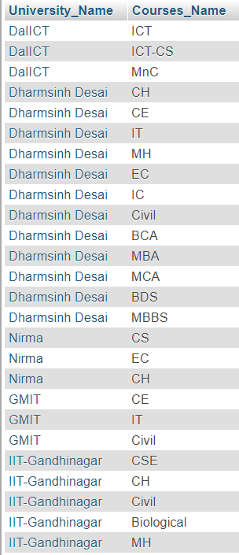

**5.2.14 Activity**

INSERT INTO `activity`(`S_ID`, `activity_Name`, `Activity_Place`, `Instruments`) VALUES ('1','Cricket','J&J Ground','');

INSERT INTO `activity`(`S_ID`, `activity_Name`, `Activity_Place`, `Instruments`) VALUES ('2','Badminton','Aloka Sports','Sitar');

INSERT INTO `activity`(`S_ID`, `activity_Name`, `Activity_Place`, `Instruments`) VALUES ('3','Football','AKA Arena','Guitar');

INSERT INTO `activity`(`S_ID`, `activity_Name`, `Activity_Place`, `Instruments`) VALUES ('4','BasketBall','Baketball COurt','');

INSERT INTO `activity`(`S_ID`, `activity_Name`, `Activity_Place`, `Instruments`) VALUES ('5','Music','RK Music','All');

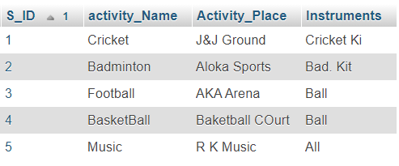

**5.3 Queries**

**5.3.1 Give the name of the Restaurant which start earliest at morning.**

* SELECT * FROM `resturant` WHERE `Re_Timing_Start`=(SELECT MIN(Re_Timing_Start) FROM `resturant`);

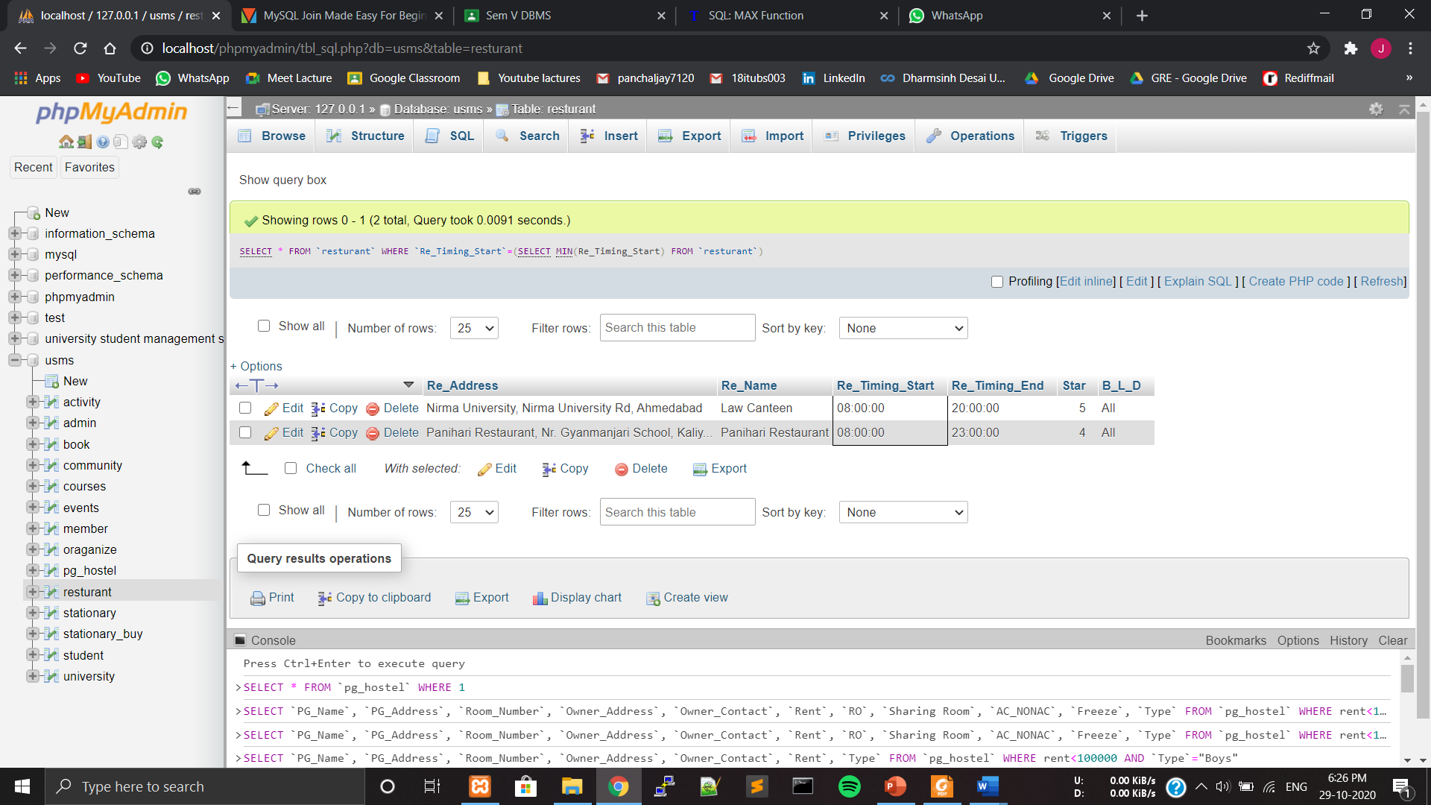

**5.3.2 Find out the name of all the students having ‘D’ as the first letter in their names.**

* Select * from `student` where `First_Name` like `D%`;

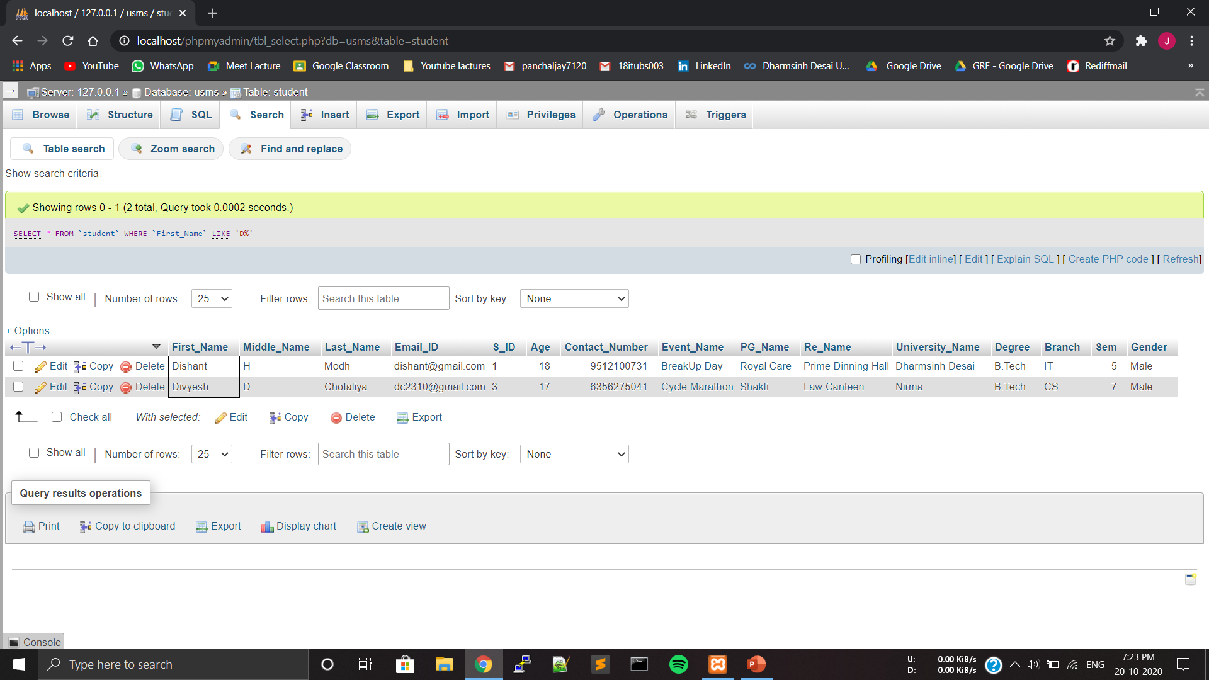

**5.3.3 Display All the Information Of pg or hostel which has RO and Freeze both facilities.**

* SELECT * FROM `pg_hostel` WHERE `RO`='yes' AND `Freeze`='yes'

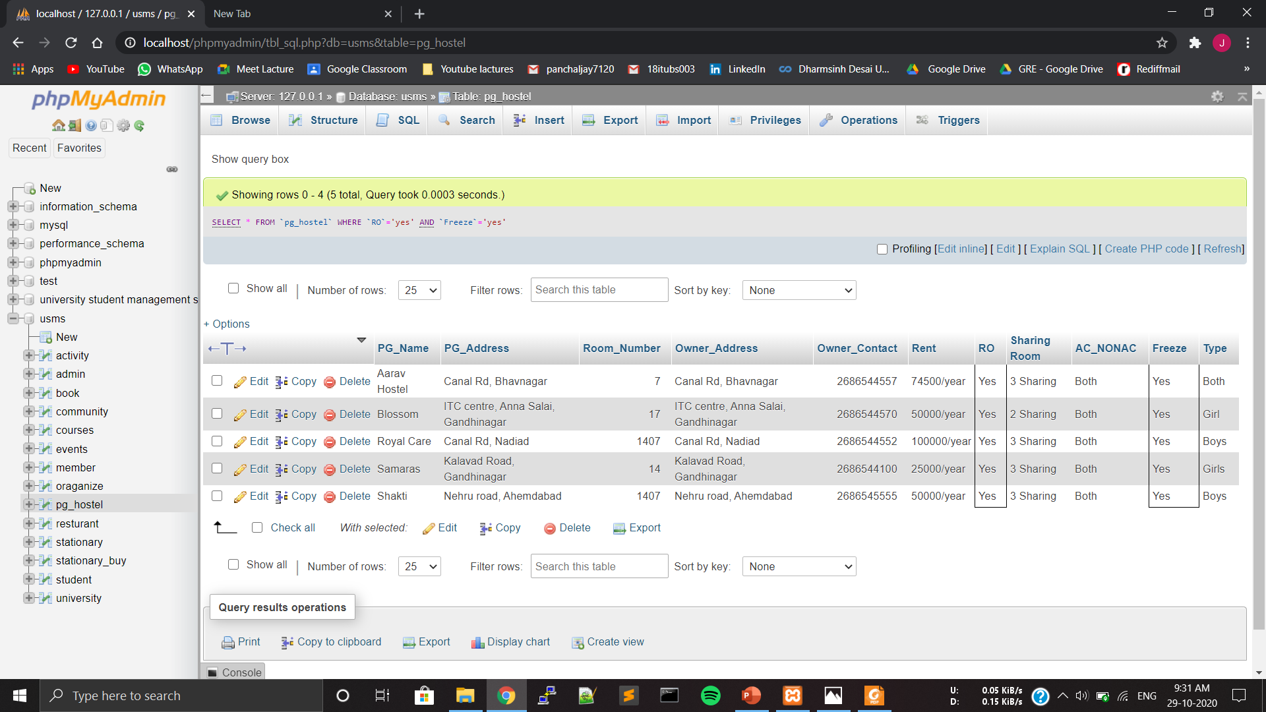

**5.3.4 Display university name Along With Number Of courses In Each university In Decreasing Order.**

* SELECT `University_Name`,COUNT(`Courses_Name`) AS 'No of Courses' FROM `courses` GROUP BY `University_Name` ORDER BY 'No of Courses' DESC

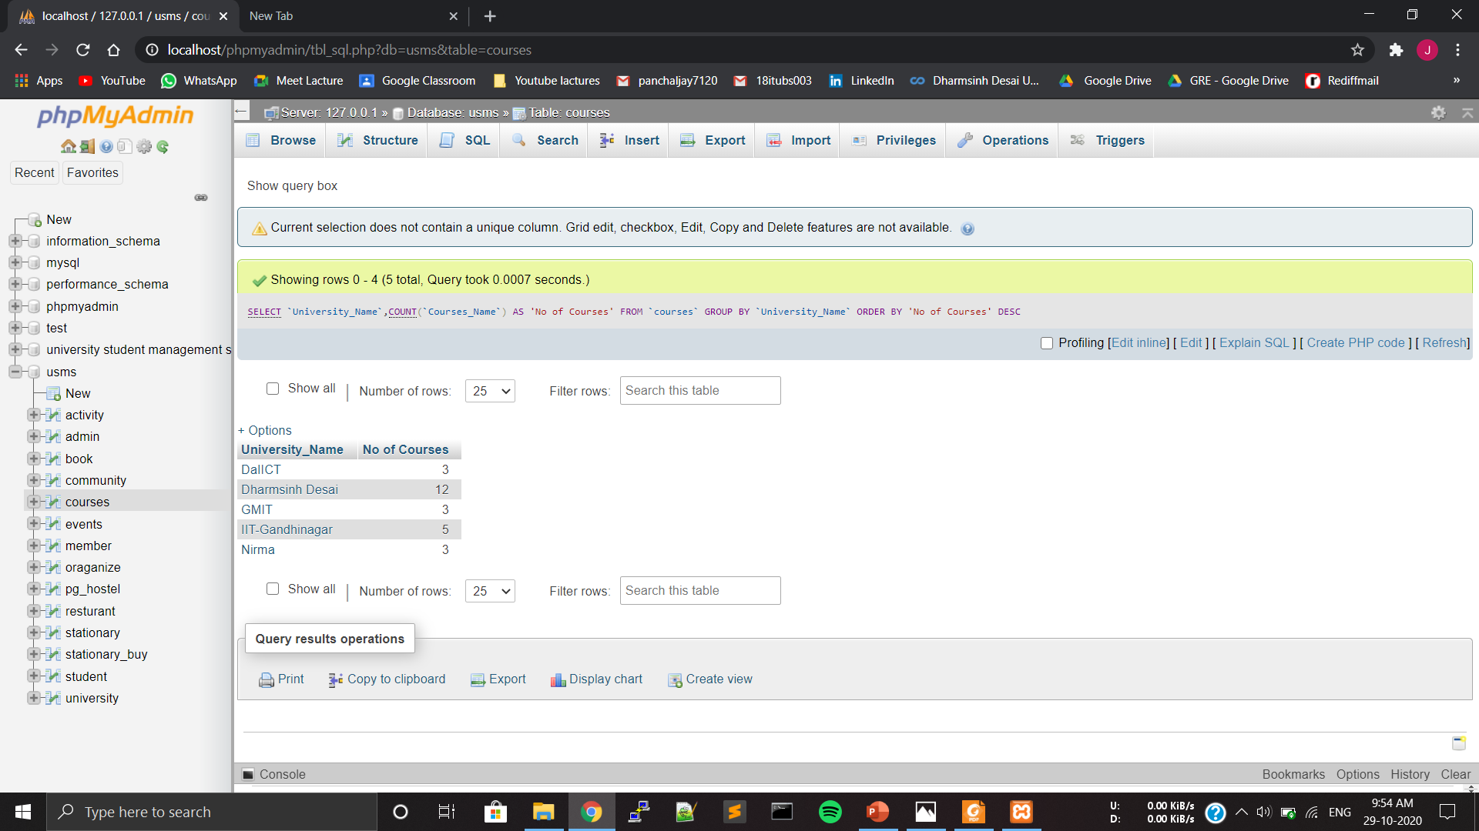

**5.3.5 Display student full name and email id whose age is between 18 to 20.**

* SELECT `First_Name`, `Middle_Name`, `Last_Name`, `Age` , `Email_ID` FROM `student` WHERE `Age` BETWEEN 18 AND 20

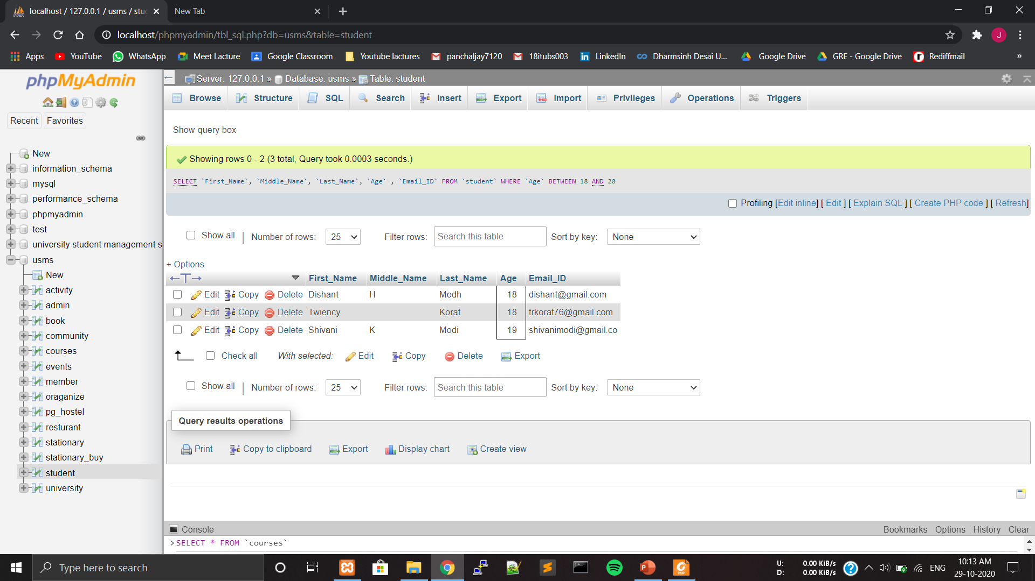

* + 1. **Give a Boys hostel name whose rent is less than 100000**
* SELECT `PG_Name`, `PG_Address`, `Room_Number`, `Owner_Address`, `Owner_Contact`, `Rent`, `Type` FROM (SELECT * FROM `pg_hostel` WHERE `Type`="Boys") WHERE rent<100000;

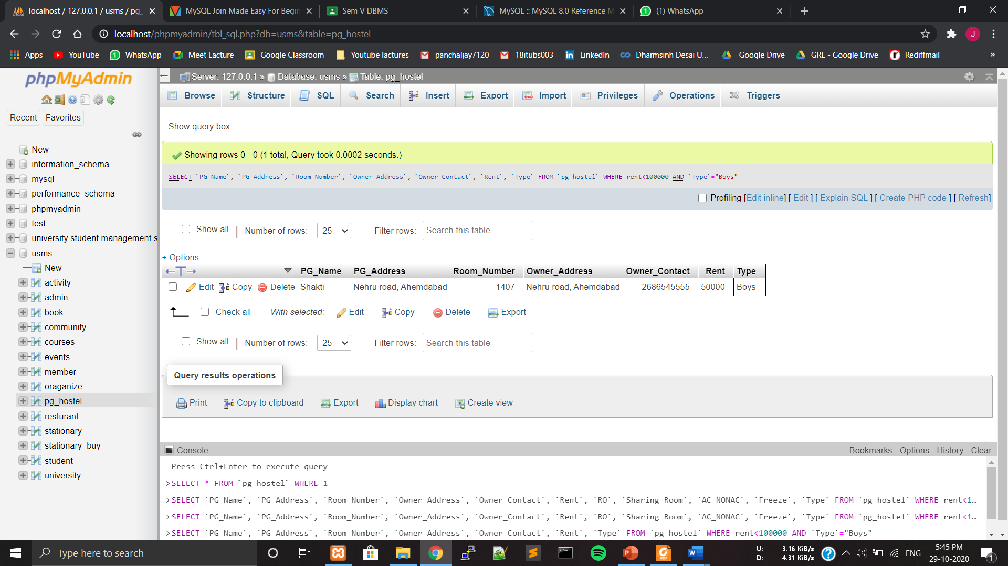

**5.3.7 Print name of the students who studies in GMIT from branch IT.**

* SELECT `First_Name`, `Middle_Name`, `Last_Name`, `Email_ID`,`Contact_Number`,`University_Name`, `Degree`, `Branch`, `Sem`, `Gender` FROM (SELECT * FROM `student` WHERE `Branch`="IT") WHERE `University_Name`="GMIT";

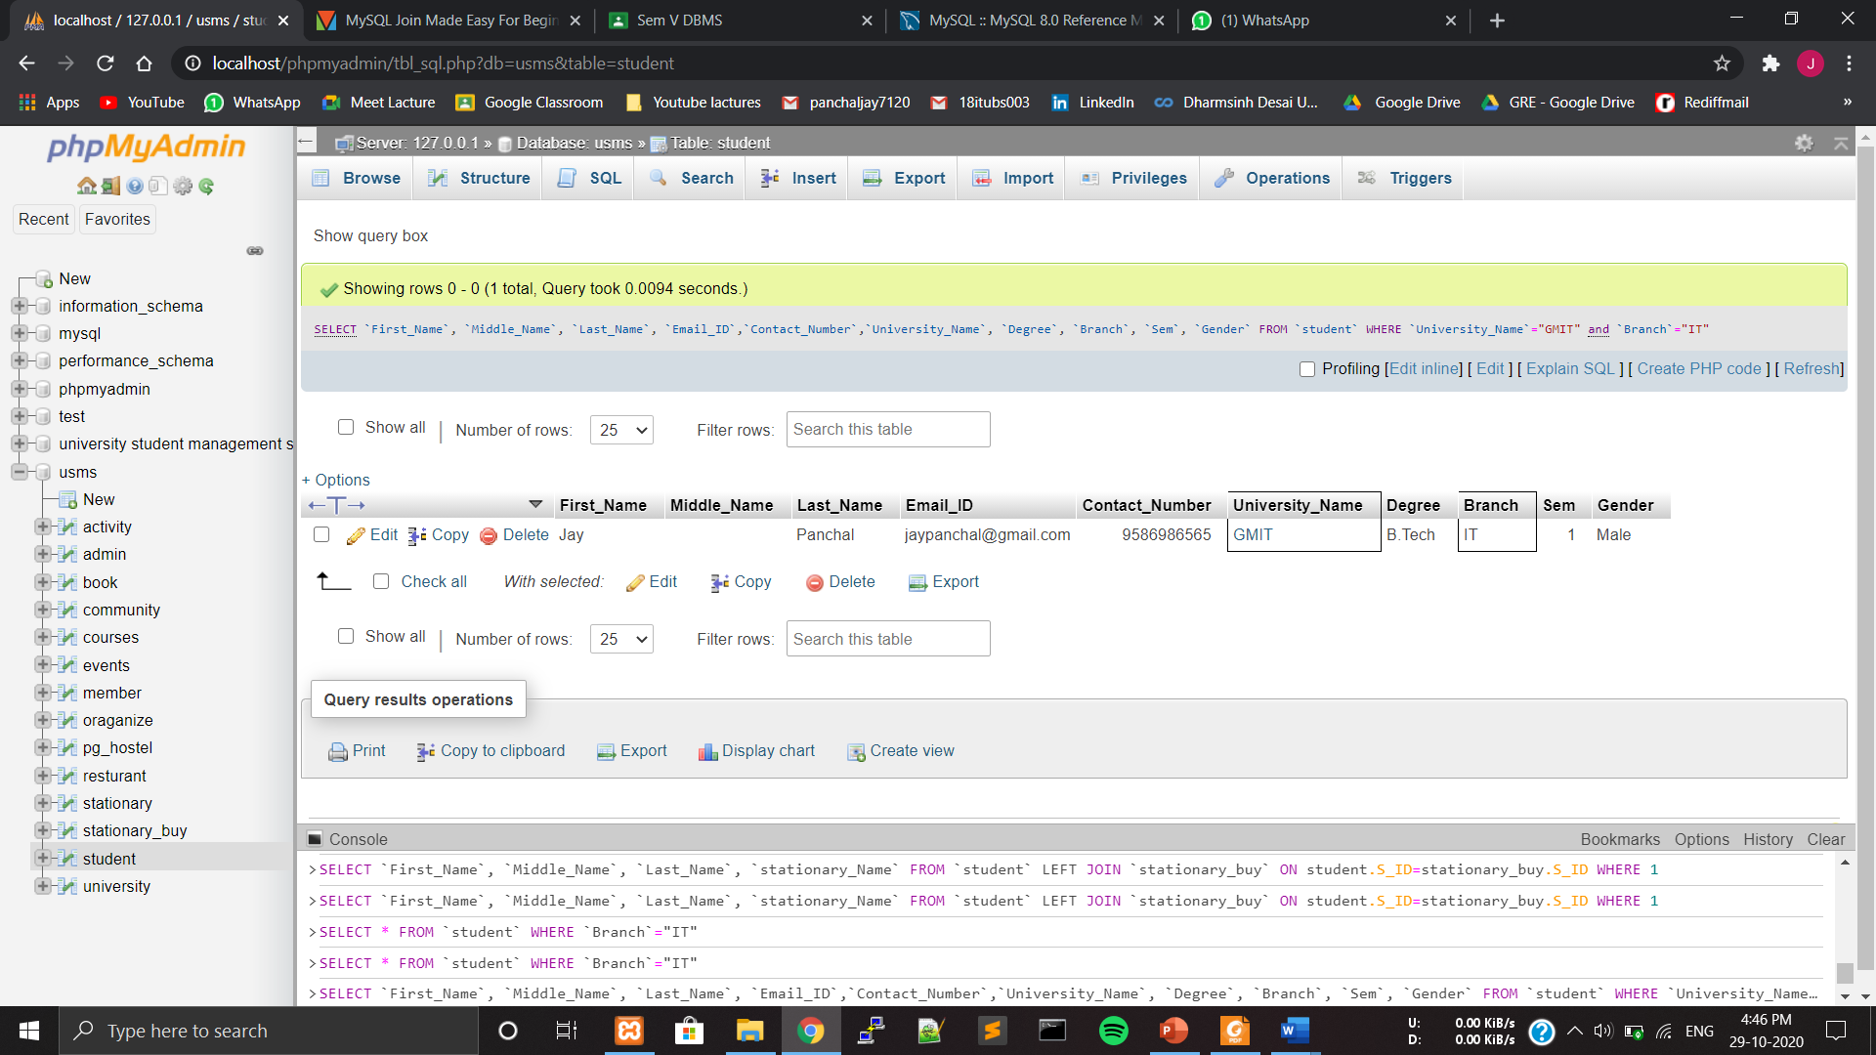

**5.3.8 Print student name whose university is located in Nadiad.**

* SELECT `First_Name`,`Middle_Name`,`Last_Name` FROM `university` INNER JOIN `student` ON university.University_Name=student.University_Name WHERE `Location`="Nadiad"

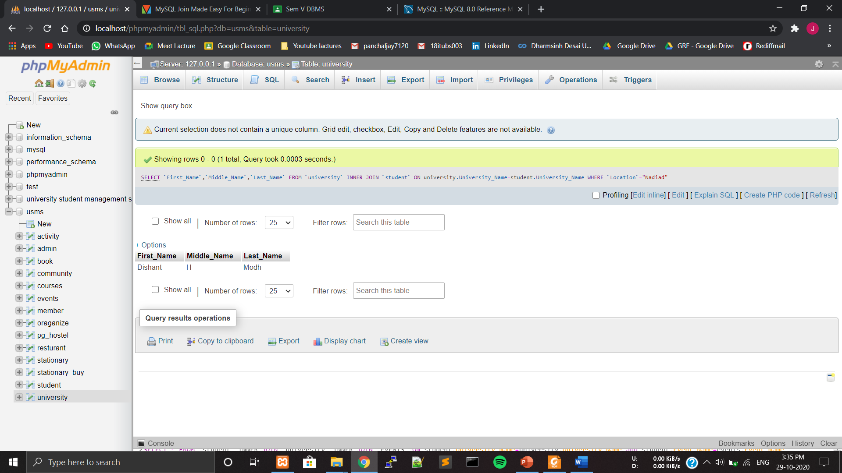

**5.3.9 Give the name of the student along with their community name.**

* SELECT `First_Name`, `Middle_Name`, `Last_Name`,`community_Name` FROM `student` RIGHT JOIN `member` ON student.S_ID=member.S_ID WHERE 1

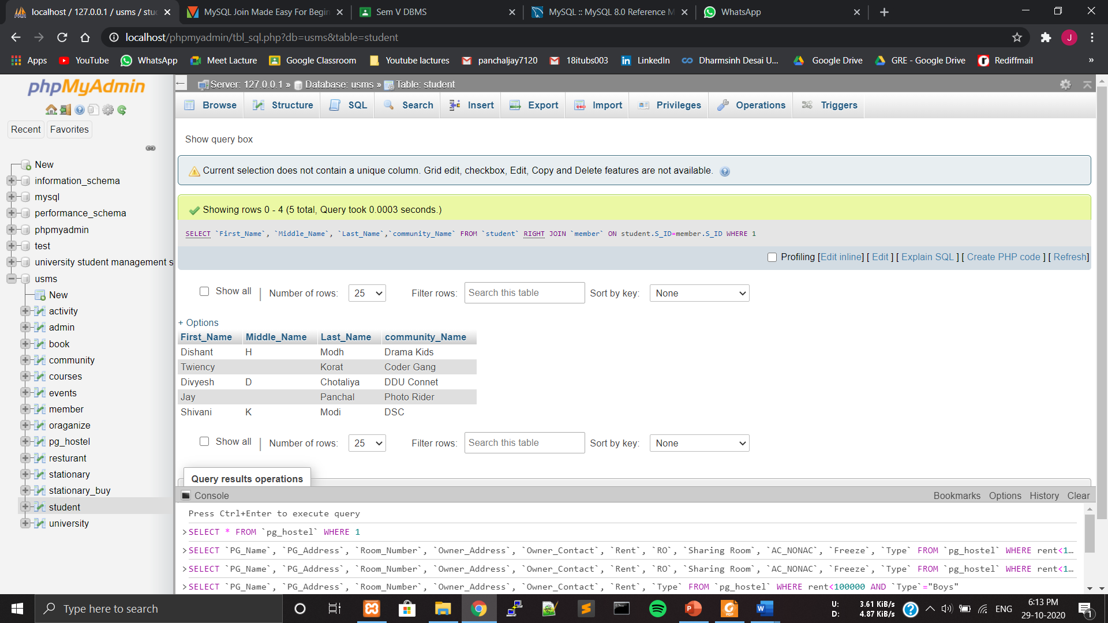

**5.3.10 Print student name from where they buy stationary items.**

* SELECT `First_Name`, `Middle_Name`, `Last_Name`, `stationary_Name` FROM `student` LEFT JOIN `stationary_buy` ON student.S_ID=stationary_buy.S_ID WHERE 1

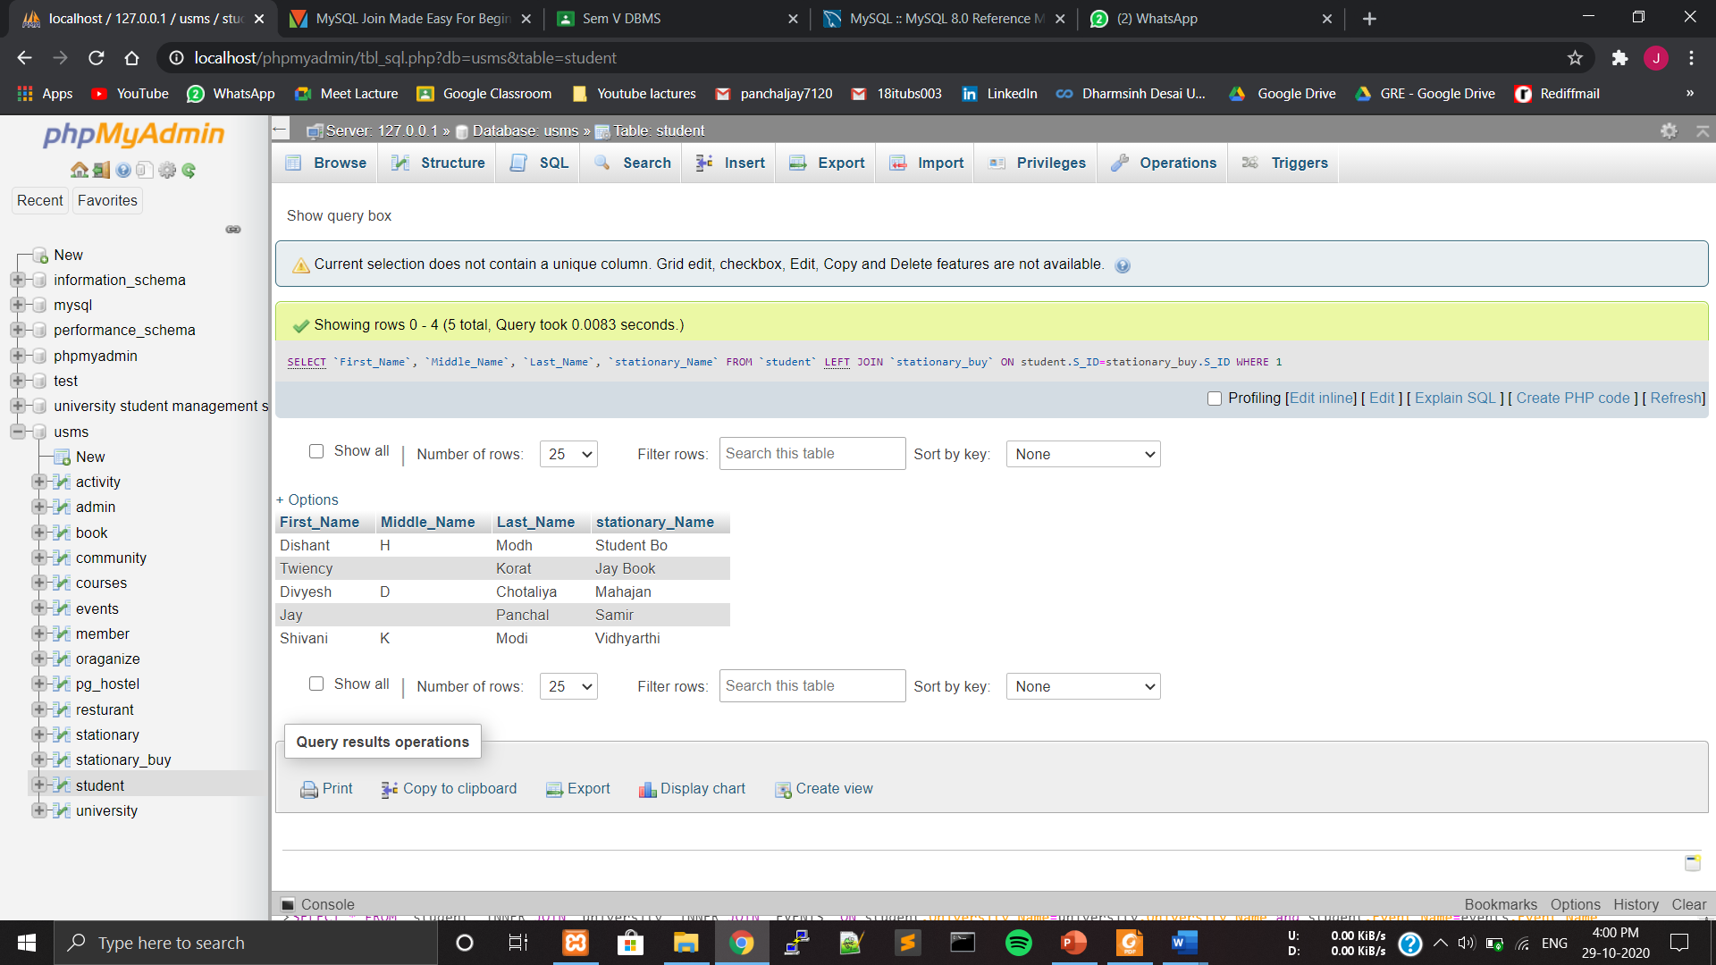

**5.4 PROCEDURES AND EXCEPTION HANDLING.**

**5.4.1 Insert Student Data After Checking All the Validation like email ID, Phone No.**

DELIMITER $$

create procedure StuData(IN first_name varchar(10),IN middle_name varchar(10),IN last_name varchar(10),IN email_id varchar(20),IN age decimal(2,0),IN Contact_Number decimal(10,0),IN event_name varchar(20),IN pg_name varchar(20),IN re_name varchar(20),IN University_name varchar(30),IN degree varchar(10),IN branch varchar(10),IN sem decimal(1,0),IN gender varchar(10))

begin

DECLARE Counter varchar(4);

select count(s_id) into Counter from student;

set counter = counter + 1;

IF email_id like '%@gmail.com' THEN

IF length(contact_number) <=> 10 THEN

IF (select count(University_name) from University u where u.university_name = University_name) then

SELECT 'University Found' AS MESSAGE;

INSERT into student VALUES (first_name,middle_name,last_name,email_id,counter,age,contact_number,event_name,pg_name,re_name,University_name,degree,branch,sem,gender);

SELECT 'YOUR DATA IS INSERTED' AS MESSAGE;

ELSE

SELECT 'Enter Valid Name' AS ERROR;

END IF;

ELSE

SELECT 'Your Mobile No. is not valid' AS ERROR;

END IF;

ELSE

SELECT 'YOUR Email-ID is not valid' AS ERROR;

END IF;

END $$

DELIMITER ;

Call StuData('Raghvendra','D','Gohil','raghav@gmail.com',18,9512100731,'BreakUP Day','Royal Care','Prime Dinning Hall','Dharmsinh Desai','B.Tech','IT',5,'Male');

* In the Student one row is Inserted.

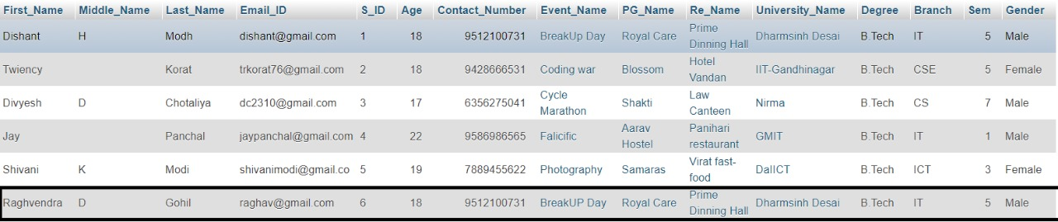

Call StuData('Raghvendra','D','Gohil','raghav@gmail.com',18,9512100,'BreakUP Day','Royal Care','Prime Dinning Hall','Dharmsinh Desai','B.Tech','IT',5,'Male');

🡪As from above query Number Format is not proper so, it will give ERROR.

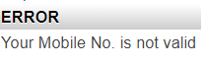

**5.5 FUNCTIONS**

**5.5.1 Show the number of Student in particular University**

DELIMITER $$

CREATE FUNCTION no_of_student(University_Name varchar(30)) RETURNS int DETERMINISTIC

BEGIN

DECLARE no int;

SELECT COUNT(S_ID) INTO no FROM student s WHERE s.University_Name=University_Name;

RETURN no;

END

$$

DELIMITER ;

SELECT University_Name, no_of_student(University_Name) FROM student GROUP BY University_Name;

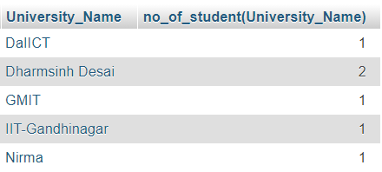

**5.6 CURSORS**

**5.6.1 Show Name Of all Restaurant’s.**

DELIMITER $$

CREATE PROCEDURE r1 (INOUT Name_List VARCHAR(1000))

BEGIN

DECLARE done INTEGER DEFAULT 0;

DECLARE r_name VARCHAR(20) DEFAULT "";

DECLARE r_cursor CURSOR FOR

SELECT Re_Name FROM resturant;

DECLARE CONTINUE HANDLER FOR NOT FOUND SET done = 1;

OPEN r_cursor;

list:LOOP

FETCH r_cursor INTO r_name;

IF done = 1 THEN

LEAVE list;

END IF;

SET Name_List = CONCAT(r_name, "-->",Name_List);

END LOOP list;

CLOSE r_cursor;

END$$

DELIMITER ;

SET @Name_List="";

CALL r1(@Name_List);

SELECT @Name_List;

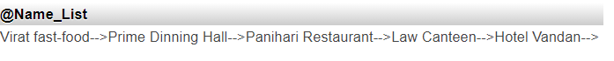

**5.7 Trigger**

**5.7.1 Update Event name into Event table and Organize table using Trigger.**

DELIMITER $$

CREATE TRIGGER e1 AFTER UPDATE ON events FOR EACH ROW

BEGIN

DECLARE v1 VARCHAR(20);

SELECT Event_Name INTO v1 FROM events WHERE Event_Name=NEW.Event_Name;

UPDATE `oraganize` SET `Event_Name`=v1 WHERE Event_Name=OLD.Event_Name;

END $$

DELIMITER ;

UPDATE `events` SET `Event_Name`="Dargon Ball" WHERE Event_Name="Coding war";

* After Update on Event Table.

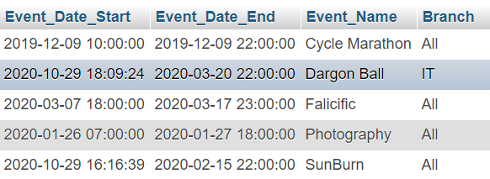

* Updated by Trigger on Organize table.

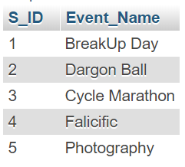

**5.7.2 Delete Community Name from Community Table and Member table using Trigger.**

DELIMITER $$

CREATE TRIGGER c1 AFTER DELETE ON community FOR EACH ROW

BEGIN

DECLARE v1 VARCHAR(20);

SELECT Community_Name INTO v1 FROM community WHERE Community_Name_Name=NEW.Community_Name;

DELETE FROM `member` WHERE Community_Name=OLD.Community_Name;

END $$

DELIMITER ;

DELETE FROM `community` WHERE Community_Name="DSC";

* After Deleting “DSC” from community table

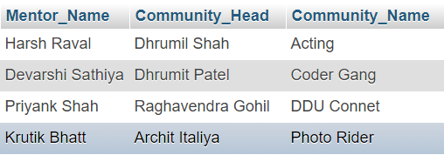

* Deleted “DSC” from Member table using DELETE Trigger

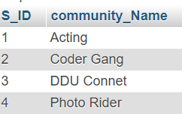

**6.Future Enhancements of the System**

* We will design Front-end Design in HTML, CSS, JavaScript and Develop Bank-end in Python
* For security purpose New Registration is done using OTP.
* Outputs, methods and user data input will be lot easy after the implement of GUI.
* We will make database more consistent and We are making this database efficient and easy to implement with huge data capacity.
* Methods and user data input will be lot easy after the implement of GUI.
* We will also add some extra features so that the users can get answer for their complaints as fast as possible.

**7.Biblography**

* We created the ER Diagram and Schema Diagram on MySQL Tool.

**Reference book:**

**Data Base System Concepts**

**-Henry F. Korth & A. Silberschatz 2nd Ed. McGraw-Hill 1991**

**Reference Book:**

* <https://www.mysqltutorial.org/>